ARC-Birdstone-Ohio-Erie County-Cooper

It was found in Erie County, Ohio. It is made out of Banded Slate. It is 4-1/2" long by 1-7/8" tall. It comes with a Thomas E. Shenk COA. It also comes with a Grade 9.5 Jeff Baker COA.

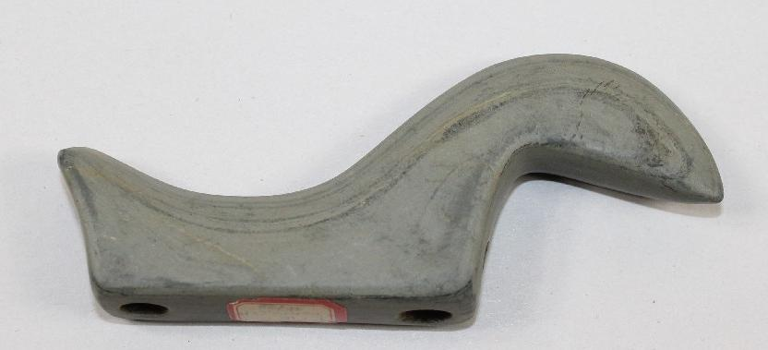

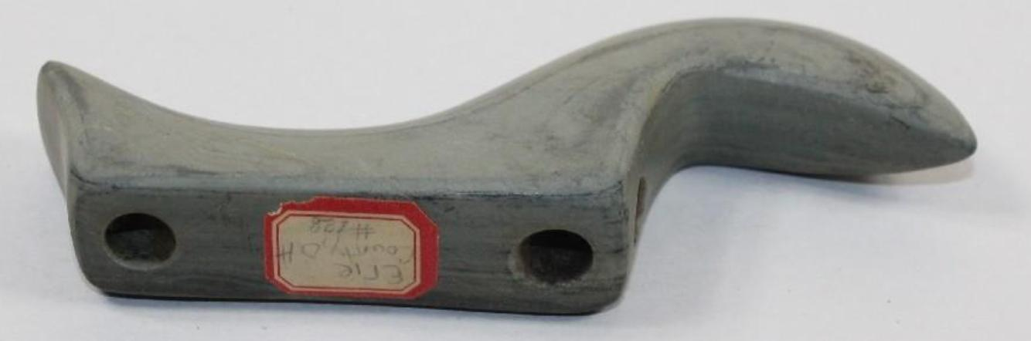

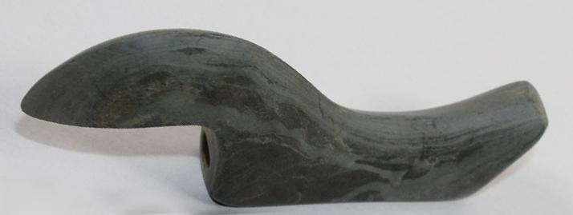

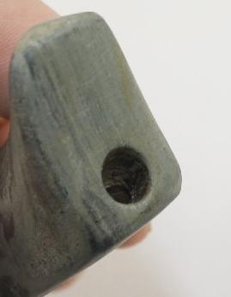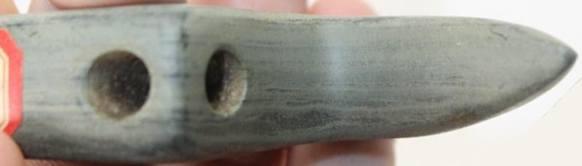

#### [OHIO BANDED SLATE BIRDSTONE W/DUAL PAPERS](http://www.ebay.com/itm/391428024643)

|  |  |
| --- | --- |
| Item price | $556.00 |
| Quantity | 1 |
| Item number | 391428024643 |
| Shipping service | USPS Priority Mail |

## Valued at $6,000.00